**FINGER SLEEVE TECHNOLOGY: A WEARABLE NAVIGATION DEVICE**

**MOHAMMED ADAMU**

**ST/CS/HND/21/050**

**A SEMINAR PRESENTED TO THE DEPARTMENT OF COMPUTER SCIENCE, SCHOOL OF SCIENCE AND TECHNOLOGY, FEDERAL POLYTECHNIC MUBI, ADAMAWA STATE, NIGERIA**

**AUGUST, 2023**

**FINGER SLEEVE TECHNOLOGY: A WEARABLE NAVIGATION DEVICE**

**MOHAMMED ADAMU**

**ST/CS/HND/21/050**

**A SEMINAR PRESENTED TO THE DEPARTMENT OF COMPUTER SCIENCE, SCHOOL OF SCIENCE AND TECHNOLOGY, FEDERAL POLYTECHNIC MUBI, ADAMAWA STATE, NIGERIA**

**IN PARTIAL FULFILLMENT OF THE REQUIREMENTS FOR THE AWARD OF HIGHER NATIONAL DIPLOMA (HND) IN COMPUTER SCIENCE**

**AUGUST, 2023**

**Abstract**

*In this seminar we present a new wearable navigation system along with embedded Human Computer Interface (HCI) model, where interaction with technology is dissolved into a day-today activity. In this type of HCI model a computer takes the input and tries to output an action that is a proactive anticipation of next action of a user. Usually, in urban areas people use voice assisted navigation systems or navigation guidelines displayed on a mobile phone. Some navigation systems are already installed on car dashboard, which needs explicit attention in order to make driving decisions. This wearable device is an index finger sleeve, which consists of vibrator modules, Bluetooth communication module and Microcontroller Unit (MCU).*

**Keywords**: haptic perception, wearable device, vibrator module, navigation device.

**Introduction**

Finger Sleeve, is a wearable navigation device, works along with the Android Smartphone. Android Operating Systems (OS) based Smartphone covers largest consumer market share, which helps us choose Android Smartphone as a GPS navigator. Here android OS based Smartphone is running a Google Map like application and providing the navigational signals to the Finger Sleeve. The user has to wear Finger Sleeve and pair it with the Smartphone running a navigational application. Finger Sleeve provides easy navigation throughout a journey (Solomon, 2014).

Wearable computing enables human to wear a computational device on body. Wearable devices can be of many types, and each address specific use case, such as smart glasses, smart wrist watch, heart monitoring headsets and many more. With the advent and growing popularity of wearable devices like the Google Glass, Fitbit Flex, Nike fuel Band, LG life Band and the Oculus rift, wearable computing is proving to be one of the major technological advancements in the 21st century. These body mounted devices are able to monitor various activities in real-time.

For a wearable navigation device, the success factor lies in the accuracy of navigational signaling and unobtrusive interaction. With Implicit Human Computer Interaction model, user need not necessarily be interacting with the computing system. Moreover, interaction with limited visual attention is often emphasized as a design goal for wearable input (Pasquero, Jerome, Scott, Stobbe, & Stonehouse, 2011; Perault & Simon, 2013; Nanayakkara & Suranga, 2013).

Further, while driving a car or riding a bike, the user is relieved from peeking into Smartphone to get current directions, saving a lot of time and avoiding un-necessary hazards.

The contributions of this seminar paper are:

(1) to determine the feasibility of the Finger Sleeve;

(2) a proof-of-concept, to use the Finger Sleeve for eyes-free navigation;

(3) Validation of potential benefits of Finger Sleeve in real life scenario.

**Components of finger sleeve**

A complete operational system using Finger Sleeve has two major parts:

a) Android OS based Smartphone (Application).

b) A Finger sleeve device.

**Advantages of Finger sleeve technology**

The system makes the authentication process quick and easy; however, it has other advantages, that are:

1. Quicker Authentication
2. Improves the Security System
3. Maximizes Convenience
4. Complete Control Over Access
5. Scalability
6. Flexible

**Disadvantages of finger sleeve**

The system may offer various advantages to enterprises; however, if you’re opting for it have a look at the disadvantages below:

1. Physical Disabilities
2. Expensive on the Pocket
3. Software Malfunction
4. Security Breaches
5. Fake Positives

**Architectural design of Finger Sleeve**

A working prototype of Finger sleeve has four modules; every module is responsible to perform a specific operation as described below:

1. HC-05: It is used to send and receive data wirelessly to/from android OS based Smartphone. Another alternative is to use Bluetooth Low Energy (BLE) module.

2. Arduino Nano: It has ATmega168 microcontroller with 16KB memory to store the code. It is responsible to run computational tasks.

3. Micro Vibrators: Two micro vibrators are used to provide a vibrational indicator of respective direction.

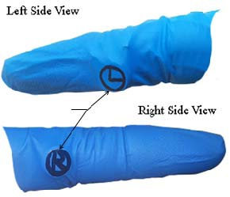

Figure 1: Typical Finger sleeve

Each vibrator corresponds to particular haptic navigational signal viz. Right or Left. Li-ion Rechargeable Battery Pack: Battery pack is responsible to power the Arduino nano. It is a rechargeable battery capable to maintain 80% capacity after 800 cycles. The smallest size of a battery pack, micro vibrator, Microcontroller Unit (MCU) and Bluetooth module helps Finger Sleeve to be worn easily (Schmidt, 2000).

Design traits of Finger Sleeve- straightforward operation, context aware input and social acceptance are inspired from Rekimoto’s design guidelines for unobstructive wearable technology. The micro vibrators will be so embedded into sleeve, one each to left, and to right side of a finger, that they are almost invisible. The arrangement of micro vibrators is shown in Figure 2. The finger sleeve should ideally be worn on proximal phalanx and some part of proximal inter-phalangeal joint. It is comfortable to use and indolent form of interaction.

**Android OS based Smartphone mobile Application**

Solomon (2014) developed a Bluetooth communication module, the mobile application, which is compatible to run on android OS version equal to 4.0 and above, that connects Finger Sleeve with a Smartphone. The Android application utilizes the map service provided by Google APIs and triggers the micro vibrators. Example scenario is shown in Figure 2.

There are few pre-requisites to be done on the Smartphone prior to start the application:

1. Start the Bluetooth and pair the Finger sleeve with Smartphone. However, this is done only once and henceforth Bluetooth connection will be automatically established.
2. Enable the GPS of Smartphone.
3. Wear Finger sleeve into the index finger.

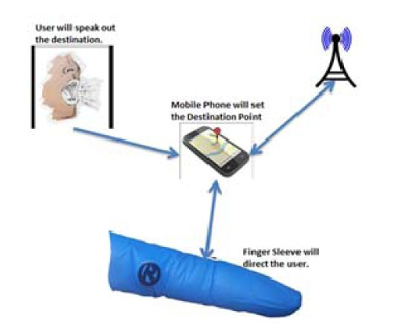

Figure 2: Android OS based Smartphone mobile Application

**Algorithm**

1. Start.
2. Set the destination point on map.
3. Draw a navigational path over a map. (Application will perform this automatically)
4. Signal the finger sleeve.
5. Start sending navigational signals to Finger Sleeve.
6. Detect the change in positions of User’s current location.
7. Repeat the steps 5 and 6 until the user arrives at the destination or application is explicitly closed.
8. Stop.

In case of normal operation above algorithm is followed. The working prototype of finger sleeve have been successfully experimented. The design of the first prototype is bearable by the user. After productizing the Finger sleeve, it will be almost invisible and difficult to trace the underline hardware modules used. This leaves a trail for a professional PCB designer to make a final Finger Sleeve Device using flexible. A navigational android application is running as expected. Thus, an android application and Finger sleeve completes the navigation system.

**CONCLUSION**

In this seminar, we have presented the experimental results and in depth analysis of the Finger Sleeve prototype for navigation during walking and driving a car tasks. Finger Sleeve, a wearable navigational assistant, shows the potential of being effective navigational beacon. Preliminary studies of user reactions and feasibility of using such wearable navigational device suggest that it is an easy to use and apropos for the navigational needs of the user in present era.

**RECOMMENDATIONS**

Such navigational system stands a base for multiple applications, which can be extended from the basic version, such as:

1. Media controller for a Smartphone.
2. A wearable pointing device.
3. Customizable keys to be used along with the mouse.
4. Finger sleeve can help visually impaired, but it has to be integrated with obstacle detection systems.

**REFERENCES**

Nanayakkara, H. & Suranga, E. (2013). Eye Ring: a finger-worn input device for seamless interactions with our surroundings. *Proceedings of the 4th Augmented Human International Conference. ACM.*

Pasquero, D., Jerome, K., Scott, J. Stobbe, & Stonehouse, N. (2011). A haptic wristwatch for eyes-free interactions. *Proceedings of the SIGCHI Conference on Human Factors in Computing Systems. ACM*.

Perrault, J. & Simon, T. (2013). Watchit: simple gestures and eyes-free interaction for wristwatches and bracelets. *Proceedings of the SIGCHI Conference on Human Factors in Computing Systems. ACM*.

Schmidt, A. (2000). Implicit Human Computer Interaction Through Context. *Springer, 4* (2-3), 191-199.

Solomon, P. (2014). Finger sleeve technology. Retrieved from <http://www.seminarsonly.com/computer%20science/finger-sleeve-seminar-report->ppt.php